Numeral

🔢 What is a Numeral in Grammar?
# Source: AI Source: Provided by: [Data Path: Persons Table -> ID Column: 1, Name_En Column: Motasem Essam] -> From: [Chatgpt (GPT-4-turbo)] on [7/24/2025]
A numeral is a word or symbol that expresses a number or quantity.
In grammar, numerals are used to indicate exact numbers, order, or amount.

📘 Definition:
# Source: AI Source: Provided by: [Data Path: Persons Table -> ID Column: 1, Name_En Column: Motasem Essam] -> From: [Chatgpt (GPT-4-turbo)] on [7/24/2025]
A numeral is a word or figure that represents a number.
It can tell us how many (cardinal) or in what order (ordinal) something is.

🔠 Types of Numerals:
# Source: AI Source: Provided by: [Data Path: Persons Table -> ID Column: 1, Name_En Column: Motasem Essam] -> From: [Chatgpt (GPT-4-turbo)] on [7/24/2025]
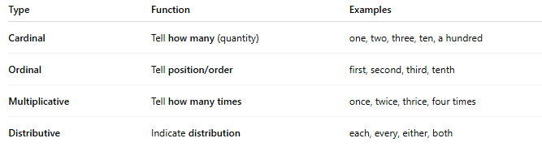
Type | Function | Examples
Cardinal | Tell how many (quantity) | one, two, three, ten, a hundred
Ordinal | Tell position/order | first, second, third, tenth
Multiplicative | Tell how many times | once, twice, thrice, four times
Distributive | Indicate distribution | each, every, either, both

🧠 Examples in Sentences:
# Source: AI Source: Provided by: [Data Path: Persons Table -> ID Column: 1, Name_En Column: Motasem Essam] -> From: [Chatgpt (GPT-4-turbo)] on [7/24/2025]
- I have three dogs. (cardinal)
- She came second in the race. (ordinal)
- He knocked twice. (multiplicative)
- Each student must bring their book. (distributive)

Numeral word vs Numbers Determiners vs Numerical Quantifiers
# Source: AI Source: Provided by: [Data Path: Persons Table -> ID Column: 1, Name_En Column: Motasem Essam] -> From: [Chatgpt (GPT-4-turbo)] on [7/24/2025]
Great question! These three terms — Numeral word, Numbers Determiners, and Numerical Quantifiers — are related but not identical. Let’s break them down clearly:

🔹 1. Numeral Word (Lexical Category)
# Source: AI Source: Provided by: [Data Path: Persons Table -> ID Column: 1, Name_En Column: Motasem Essam] -> From: [Chatgpt (GPT-4-turbo)] on [7/24/2025]
- A numeral is a word (or morpheme) that expresses number or quantity.
- It is a word class in grammar, like noun or verb.
- Numerals can function as determiners, adjectives, pronouns, nouns, or adverbs depending on the context.
✅ Includes:
- Cardinals: one, two, ten, a thousand
- Ordinals: first, second, tenth
- Multipliers: double, triple
- Fractions: half, one-third
- Distributives: each, every
- Collectives: dozen, pair
- Approximate numerals: several, some (sometimes disputed)

🔹 2. Numbers Determiners (Syntactic Function)
# Source: AI Source: Provided by: [Data Path: Persons Table -> ID Column: 1, Name_En Column: Motasem Essam] -> From: [Chatgpt (GPT-4-turbo)] on [7/24/2025]
- This refers to numerals functioning specifically as determiners, meaning they modify nouns directly to indicate how many or which one.
- So, this is not a separate category, but a function that numeral words (and some quantifiers) can serve.
✅ Examples:
- Three cats slept. → Cardinal as determiner
- First prize was awarded. → Ordinal as determiner
- Each student passed. → Distributive numeral as determiner
- Half the group left. → Fraction as determiner
🚫 Not all numeral words are determiners:
- “Three” in I saw three = noun, not a determiner.
- “Once” in He tried once = adverb, not a determiner.

🔹 3. Numerical Quantifiers (Semantic Role)
# Source: AI Source: Provided by: [Data Path: Persons Table -> ID Column: 1, Name_En Column: Motasem Essam] -> From: [Chatgpt (GPT-4-turbo)] on [7/24/2025]
- These are quantifiers that express amount or number, whether exact or approximate.
- This is a semantic category, based on meaning, not strictly word class or syntax.
✅ Includes:
- Exact Numerals: one, two, ten, etc.
- Approximate Numerals: many, several, few, some
- Fractions: half, one-third
- Multipliers: twice, double
- Expressions like about ten, more than three, etc.
🚫 Not all numerical quantifiers are determiners:
- Several in “Several were missing.” → Quantifier, not functioning as determiner here.
- About ten in “About ten people came.” → Quantifier phrase.

✅ Summary Comparison Table
# Source: AI Source: Provided by: [Data Path: Persons Table -> ID Column: 1, Name_En Column: Motasem Essam] -> From: [Chatgpt (GPT-4-turbo)] on [7/24/2025]
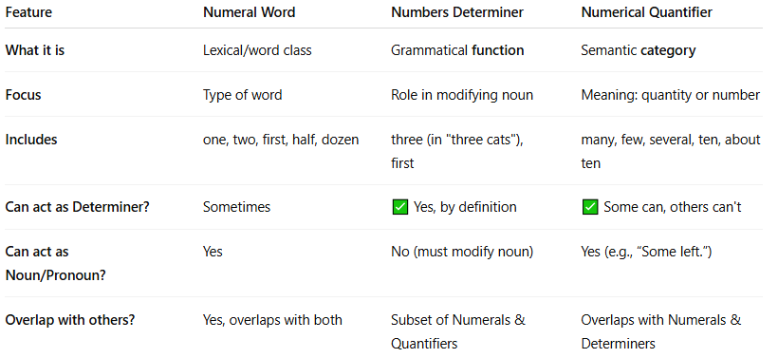
Feature | Numeral Word | Numbers Determiner | Numerical Quantifier
What it is | Lexical/word class | Grammatical function | Semantic category
Focus | Type of word | Role in modifying noun | Meaning: quantity or number
Includes | one, two, first, half, dozen | three (in "three cats"), first | many, few, several, ten, about ten
Can act as Determiner? | Sometimes | ✅ Yes, by definition | ✅ Some can, others can't
Can act as Noun/Pronoun? | Yes | No (must modify noun) | Yes (e.g., “Some left.”)
Overlap with others? | Yes, overlaps with both | Subset of Numerals & Quantifiers | Overlaps with Numerals & Determiners

🎯 Key Points to Remember
# Source: AI Source: Provided by: [Data Path: Persons Table -> ID Column: 1, Name_En Column: Motasem Essam] -> From: [Chatgpt (GPT-4-turbo)] on [7/24/2025]
- Numeral word = type of word
- Numbers determiner = when a numeral is used to modify a noun
- Numerical quantifier = any word or phrase that expresses quantity, whether exact (like “ten”) or vague (like “several”)

✅ Summary:
# Source: AI Source: Provided by: [Data Path: Persons Table -> ID Column: 1, Name_En Column: Motasem Essam] -> From: [Chatgpt (GPT-4-turbo)] on [7/24/2025]
A numeral is a word or symbol that shows a number, quantity, or order.
It helps us count, rank, or describe how many or in what sequence.

